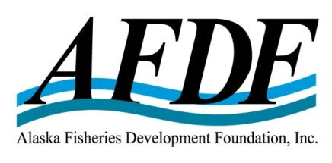
December 4, 2017

RE: Update on MSC & RFM Pacific Cod Certifications

Board of Directors

Jan Jacobs – President
Harvester, Region IV
American Seafoods Company

Ken Simpson – Vice President
Harvester, Region II
F/V Lady Simpson

Trevor Sande - Treasurer
Harvester, Region I
Marble Seafoods

Mark Scheer - Secretary
Service Sector
Williams Kastner

Al Burch
Harvester, Region III
Alaska Whitefish Trawlers Association

Jim Denning
Service Sector
AquaStar

Tom Enlow
Processor, At-large
UniSea

Buck Laukitis
Harvester, At-Large
Magic Fish Company

Chris Mierzejek
Processor, At-large
Aleutian Pribilof Island Community Development Assoc.

Stefanie Moreland
Processor, At-large
Trident Seafoods

John Sund
Service Sector
Stellar North LLC

Dear MSC & RFM Pacific Cod Client Group,

The Alaska Fisheries Development Foundation (AFDF) is the Client for Alaska’s Pacific Cod fishery for the Marine Stewardship Council (MSC) program (first certified in 2010), and for the Alaska Seafood Marketing Institute (ASMI) Responsible Fisheries Management (RFM) program, beginning with the 2nd audit in 2015 (the fishery was first certified under RFM in 2013). Both MSC and RFM certify a fishery as sustainably managed for a period of five years, with required annual surveillance audits. After five years, the fishery must be re-certified to maintain the certificate.

Review of Alaska RFM Program
Maintaining choice in sustainability certifications is critical. ASMI is the owner of Alaska’s alternative to MSC certification, called the Responsible Fisheries Management (RFM) Program. In 2014, ASMI took full ownership of the RFM Program in order to increase transparency and improve the program for greater market acceptance.

In July, 2016, the RFM Program became the first certification program successfully benchmarked against the Global Sustainable Seafood Initiative (GSSI) tool (see info attached). This recognition demonstrates the rigor of the RFM program and marks an important milestone for enabling buyers to have an informed choice for the procurement of certified seafood. In 2017, Walmart, Kroger and Metro Group have all made commitments to accept seafood certified by a GSSI benchmarked program, such as RFM. It is expected that more major retailers will continue to adopt seafood sourcing policies that include GSSI benchmarked programs, such as RFM.

AFDF’s Responsibility as the Client
As the Client, AFDF is responsible for management of the MSC and RFM certification program and certificate for the Pacific Cod fishery. To do so, AFDF undertakes the following activities:
- Negotiates contracts with the MSC and RFM Certification Bodies for assessments and annual audits
- Organizes and facilitate required site visits;
- Provides materials and information to the Assessment Teams
- Acts as an intermediary between the Assessment Team, management agencies and industry
- Manages completion of conditions / non-conformances on certification (none for Pacific Cod)
- Reviews and comments on draft reports prior to posting
- Manages the budget, invoicing, payments, and collection of funds from the Client Group members
- Manages the Client Group List used to verify eligibility for Chain of Custody

Update on MSC certification activities
In 2014, AFDF collected funds from the Client Group for the five-year MSC re-certification which was completed in June, 2015. In 2016, AFDF collected funds from the Client Group for the first surveillance audit which was completed in 2016. Earlier in 2017, the 2nd audit began and should be completed within 2 months. The 3rd audit is planned for 2018. AFDF is now collecting funds for work completed in 2017 and to be completed in 2018. AFDF continues to hire MRAG as the third- party certification body (CB), the scores remain high for MSC P-cod certification and there are no conditions on the certification. AFDF also continues to coordinate with the Clients for the flatfish and pollock MSC certifications to conduct the three fishery certifications and audits in parallel in order to keep costs down to industry.

Consequently, the MSC certification continues to remain valid through June 17, 2020, and can be applied to catches taken from this fishery by companies with appropriate Chain of Custody (CoC) certification in place, which includes participation in the MSC P-cod Client Group. Participants can download the fishery certificates for the applicable regions and gear types here. However, the continued certification of the fishery is contingent on the fishery successfully completing the annual surveillance requirements.

The P-cod fishery is now eligible for a new, reduced level of surveillance due to its high scores and lack of conditions. This reduced level of surveillance is called “level 1 surveillance” and includes 2 reviews of information, 1 off-site surveillance audit, and 1 on-site surveillance audit through 2019. This is excellent news for the industry, because it reduces cost to the industry.

Association of Sustainable Fisheries & future changes to MSC
The Association of Sustainable Fisheries (ASF) is an international group that represents the interests of all MSC Client Fisheries worldwide. AFDF joined ASF in 2017, and annual membership dues are $3,000 (see budget). ASF comments and coordinates responses from the Client Groups to MSC’s consultation on potential changes to the MSC certification program. Over the past 2 years, ASF has commented on approximately 13 separate potential changes to the MSC program, some of the most impactful to Clients are the following: inclusion of labor standard practices, definition of the unit of assessment, and mass balance in the Chain of Custody (CoC). Industry believes the uncertainty of the evolution of the MSC program in the future is a compelling reason to support choice in sustainability certification which maintains access to as many markets as possible for the sale of Alaska Seafood.

Socially Responsible Practices on Commercial Fishing Vessels
Related to the topic of labor practices, AFDF recently received a grant from NOAA to maintain global market access for Alaska seafood by documenting socially responsible practices (SRPs) on fishing vessels. Over the next year, AFDF will be working with the United Fishermen of Alaska (UFA) and seafood processors to create a final document which demonstrates socially responsible labor practices employed on fishing vessels with a low-risk approach to verification of fishing fleets rather than a third-party vessel inspection/certification requirement. One of the motivations to completing this project is push-back against the inclusion of SRPs in sustainability certification programs.

Update on RFM certification activities
In 2015 and 2016, the 2nd and 3rd surveillance audits were completed using Global Trust as the third-party CB. In 2017, AFDF issued an RFP and consequently hired DNV to complete the fourth surveillance audit and five-year re-assessment. [Maintaining competition and choice between CBs is a good way to ensure downward pressure on costs to industry.] The fourth surveillance audit was completed in 2017 and the RFM Assessment Team is currently completing the re-assessment, which will be in place by April, 2018. Similar to the MSC P-cod certification, the RFM P-cod certification has received high scores and has no non-conformances.

Mr. Dave Gaudet has also been hired as a consultant to help facilitate the site visits, information collection, and report preparation for both the MSC and RFM certifications. Mr. Gaudet also works for AFDF to facilitate the RFM Salmon certification and he works for PSPA to facilitate the MSC Salmon certification. Consequently, he has a good understanding of both certification programs from the perspective of more than one fishery.

I look forward to continuing this work on behalf of the Alaska seafood industry to provide continued MSC and RFM certification of P-cod and sharing of the certificate through an open and transparent Client Group. Please call or email me if you have any questions.

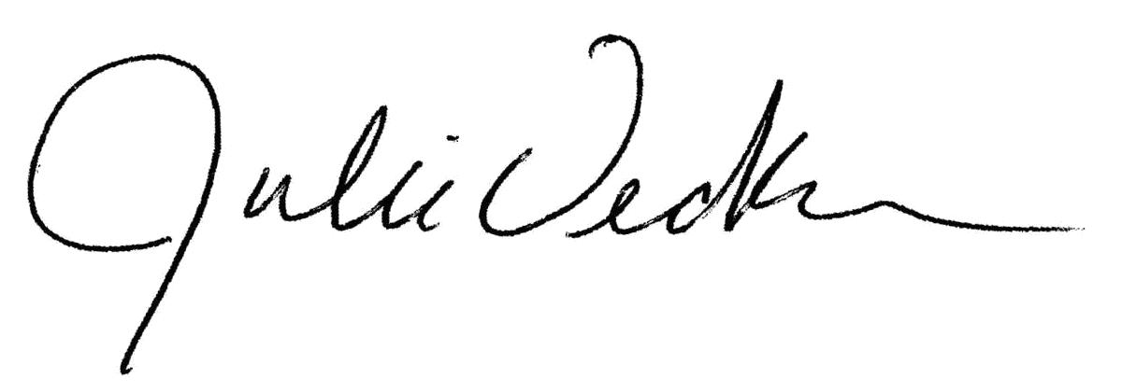
Sincerely,

Julie Decker, Executive Director
jdecker@afdf.org

