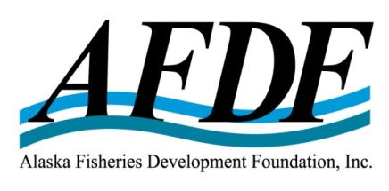
April 25, 2018

RE: Updates as a result of Industry meeting

Board of Directors

Jan Jacobs – President
Harvester, Region IV
American Seafoods Company

Ken Simpson – Vice President
Harvester, Region II
F/V Lady Simpson

Trevor Sande - Treasurer
Harvester, Region I
Marble Seafoods

Mark Scheer - Secretary
Service Sector
Williams Kastner

Al Burch
Harvester, Region III
Alaska Whitefish Trawlers Association

Jim Denning
Service Sector
AquaStar

Tom Enlow
Processor, At-large
UniSea

Buck Laukitis
Harvester, At-Large
Magic Fish Company

Chris Mierzejek
Processor, At-large
Aleutian Pribilof Island Community Development Assoc.

Stefanie Moreland
Processor, At-large
Trident Seafoods

Glenn Reed
Processor, At-large
Pacific Seafood Processors Assoc.

John Sund
Service Sector
Stellar North LLC

Dear MSC & RFM Pacific Cod Client Group,

On December 4th, 2017, AFDF hosted a meeting in Anchorage for industry members of the MSC and RFM Pacific Cod Client Group. At that time, and in the month that followed, I heard several requests on behalf of industry. I am writing to explain several changes we made to the budget and invoicing process in response to those requests.

Create Annual Budgets with Cost Sharing by Sector Based on Current ABC
I had previously presented one budget for MSC covering two years, plus one budget for RFM covering two years. The cost-sharing for these budgets was based on the 2014 Acceptable Biological Catch (ABC) in Bering Sea / Aleutian Islands (BSAI) and Gulf of Alaska (GOA). Due to significant recent changes to the ABC in the GOA, industry requested to instead split the budget into annual budgets, which corresponded with the ABC for that calendar year which would more accurately reflect a fair and equitable cost sharing. Consequently, we worked with industry to split the budget into separate budgets for years 2017 and 2018 and applied the corresponding cost sharing based on the ABC for each year.

Invoice Annually in Future
Industry requested that AFDF invoice annually in the future. Annual invoicing will allow for regular expectations and budgeting for companies. It will also allow for updated cost sharing based on ABC numbers set in December at the North Pacific Fishery Management Council (NPFMC) meetings. Beginning December, 2018, AFDF will begin annual invoicing.

Include MSC and RFM costs in Single Budget
Industry also requested that the costs to manage the RFM P-cod certification be rolled into the MSC P-cod budget. The RFM costs are significantly lower than MSC costs for industry, since ASMI is still paying for the largest cost (certification body) in the RFM program. This still allows for the RFM costs to be identified separately and simplifies invoicing.

FYI – MSC Info
Additionally included is information about the MSC Recertification Fund, which will help offset costs to fishery clients for the Certification Body (CB) during the five-year recertification process in years 2019-2020 by approximately $75,000.

I look forward to continuing this work on behalf of the Alaska seafood industry to provide continued MSC and RFM certification of P-cod and sharing of the certificate through an open and transparent Client Group. Please call or email me if you have any questions.

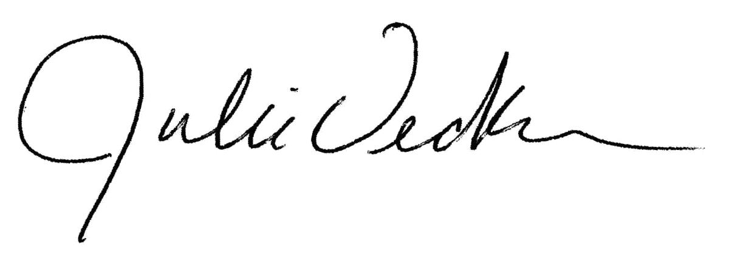
Sincerely,

Julie Decker, Executive Director
jdecker@afdf.org

